MY PRINCESS

-Shiv Dutt, Indraprastha Engineering college

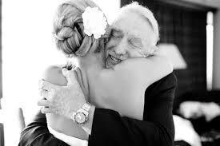

I remember the first day she called me 'pa', I was more than happy. I remember how she used to cling around my feet; I remember she used to cry, not letting me go, even for a second. Since the day she was born I knew she would leave me one day. Today is the day, when my 'princess' is on a verge of becoming a "Queen". I remember how she used to say "I won’t leave you ever, dad" but I knew the law of nature, she has to go. My sight might not be clear but my vision still is

.

I remember all those things she used to do, she used to say, I remember her innocence, her fights. She is the happiness of my world and today I am handing over my life to her one true love. For twenty four years I nourished her with my blood and sweat and today at this moment I am left with nothing…nothing but a few memories… memories of my princess. I know a king knows well how to treat his Queen but still being a father I care for her well-being. I hope he takes care of my princess and endures her with his love. My sweet little princess.

